***Project description***

* ***INTRODUCTION:-***

**Placement record analysis is an essential practice to find out the hidden relations between the states of the students and the employer companies.**

**due to the analysis of these records the users will sure be able to find out that what kind of factors that DOES matters in actual real life seniors.**

* ***FEATURES:-***

It does help to find out what the companies  are looking for in an eligible job candidate.

It helps candidates to find out which of  their fields of skills need to be improved.

Companies can find out where to look for job candidates.

Colleges through this analysis of the data how the level of their students is  compared to the rest of the sector.

* ***Room For Improvements In The Future:-***

1. Better And Faster Performance
2. Charts For Data Points
3. Recommendations For The Improvement
4. Reduce Duplication
5. Decentralize The Whole System

* ***Funaction:-***

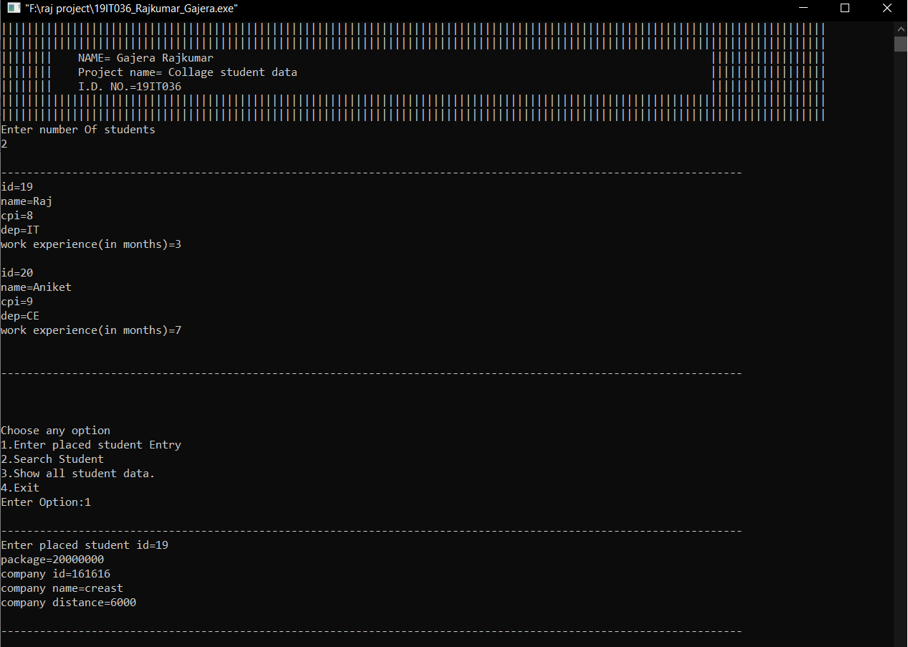

1. ***Placed student entry***

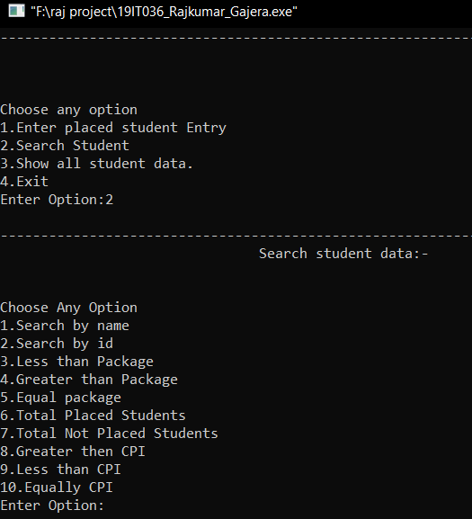 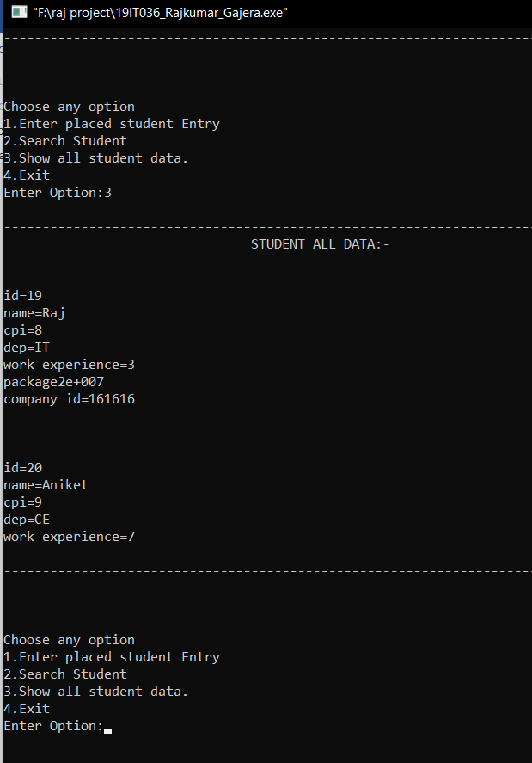

1. ***Search student by 3. Show all student data.***
2. ***Exit***

* ***CONCLUSION:-***

In this new era of cut throat competition competition even the slightest edge over your competitors can result in to Job and unemployment,

And the best way to get leaps ahead from your competition is to use the data and the hidden information that is in this data.

We are already seeing the use of the big data generated by the billions of internet connected devices to improve the lifestyle of us humans .

By using MAPF System you can also get that greatly benefit from data.